EXPLORING COMPUTER AND STORYBOOK INTERVENTIONS

FOR CHILDREN WITH HIGH FUNCTIONING AUTISM

Teresa Kay Armstrong

Marie Tejero Hughes

University of Illinois

Comprehension is a crucial academic skill that is necessary for independent living. Unfortunately many children with autism often exhibit difficulties being able to interpret and comprehend written language. There is limited research on effective comprehension practices to enhance the comprehension development of children with autism. Therefore, the purpose of this study was to investigate the impact of two repeated reading interventions (computer and storybook) on the comprehension of five children with autism. Findings indicated that several of the children performed better than would otherwise have been expected for both interventions. Neither of the computer or storybook interventions showed to be more beneficial than the other, indicating that these interventions may both be effective in increasing some children’s listening comprehension of text.

Comprehension is a crucial academic skill for everyone, including children with autism, since it is necessary for independent living and pleasure (Nation & Norbury, 2005). However, there is a paucity of research in academics in general and literacy in particular in children with autism (e.g., Whalon, Al Otaiba, & Delano, 2009). Comprehension is related to several cognitive skills including language and social development, skills critical for children with autism (Nation, Clarke, Wright, & William, 2006). Kluth and Chandler-Olcott (2008) noted that learning to read might also encourage individuals with autism and other individuals with disabilities to attain greater post school outcomes. Unfortunately, opportunities for children with autism to develop literacy depend upon a number of factors including the perceptions of others. Many teachers and parents of children with significant disabilities rank literacy priorities low for this group of children and, consequently, target alternative behaviors during intervention, limiting the student’s access to literacy-related activities

The ultimate goal of reading is to understand what has been written, and although the ability to decode individual first words is an important first step, it is no guarantee that adequate comprehension will follow (Nation & Norbury, 2005). Children with autism often exhibit an inability to interpret and comprehend information. Although children with autism frequently have problems with comprehension, the difficulties they experience may be consistent with the literature regarding reading comprehension of children developing typically (Rayner, Denholm, & Sigafoos, 2009). Some researchers have explained that the difficulty children with autism often have comprehending information directly relates to working memory, language and abstract information processing problems (Gabig, 2008). Despite many children with autism’s ability to decode texts as accurately as other children, in many cases they have poorer comprehension especially at making inferences (Huemer & Mann, 2010). Poor comprehenders also show weaknesses in their productions of both spoken and written narratives including producing narratives that captured less of the story context and use a more simplistic story structure (Craig & Nation, 2006).

It is likely that many effective evidence based comprehension strategies could prove beneficial for children with autism (Chandler-Olcott & Kluth, 2009). Repeated reading is a widely known comprehension procedure that involves repeatedly reading passages or stories to develop fluency and increase comprehension. Both independent read alouds and read along forms of repeated reading facilitate increases in reading rate, word accuracy, expression, and comprehension of practiced passages (Nelson, Alber, & Gordy, 2004). Improvements in comprehension have been reported in a number of repeated reading studies with children with disabilities (e.g., Therrien & Hughes, 2008). In one peer tutoring study, for example, the intervention of repeated reading was used with children with autism to increase fluency and comprehension with results indicating that gains were made in these areas (Kamps, Barbetta, Leonard, & Delquadri, 1994).

A review of repeated reading research has shown it to be highly effective in improving the reading comprehension of children with learning and mild disabilities (Nelson et al., 2004; Singh & Singh, 1984; Therrien, Wickstrom, & Jones, 2006). Retelling and the answering of comprehension questions are also common measures of reading comprehension in reading intervention studies (Sindelar, Monda & O’Shea, 1990; Jones, 2009). Rereading has been noted for many years now to be as effective as the visual strategies of summarizing and outlining for enhancing comprehension (Anderson, 1980; Howe & Singer, 1975). Barnett and Seefeldt (1989) found repeated reading improved retention of factual information for both good and poor readers, with good readers benefiting even more when focusing on higher levels of information. Furthermore, use of repeated readings along with a scaffolding approach was found to be effective with children with disabilities including those with autism (Kamps et al., 1994). Combined reading interventions using repeated reading and an additional strategy such as question generation were found to be effective in increasing children’s overall reading comprehension (Therrien et al., 2006).

In addition to focusing on developing comprehension strategies to enhance learning, a structured environment is also essential for children with autism (Carnahan, Musti-Rao, & Bailey, 2009), because they often have difficulties in assembling fragmented information into a meaningful whole and in decoding abstract information (Frith, 1989). Technology used to assist learning is suggested by many as one potential means of addressing these needs (e.g., Mechling, Gast, & Cronin, 2006). If computer assisted instruction (CAI) is as effective as that delivered by the teacher in certain circumstance, then the computer may be an effective tool for reinforcing or practicing skills previous taught by the teacher. This means that teachers of children with autism have another tool with which to provide individualized instruction (Williams, Wright, Callaghan, & Coughlan, 2002). In addition, research with children with autism has shown that computers are highly motivating to them and it helps to increase their time on task, which leads to reading improvement (Williams et al., 2002). Several studies that investigated the effects of CAI have noted the positive benefits to children with autism (e.g., Moore & Calvert, 2000; Tjus, Heimann, & Nelson, 2001). Computer interventions that involve having children read aloud with a computer have also been found to increase comprehension (Basil & Reyes, 2003).

Given the success of several comprehension interventions and the need to develop academic strategies for this population (Whalon & Hart, 2011), more research for such efforts are warranted. In this study, high functioning children with autism were randomly presented with two interventions: reading along with a book as it was read by an adult and reading along with a book on a computer. The purpose was to determine if either of two interventions (computer, storybook) would enhance the listening comprehension of high function children with autism.

Methods

Participants
Five high functioning children with autism who attended schools in a large metropolitan area in the United States participated in the study. High functioning children with autism were selected due to their typically strong lexical and cognitive skills. Nine parents expressed an interest in the study and gave permission for their child to participate. Children were randomly selected from this pool one at a time and their initial inclusionary status was confirmed through a review of school records (e.g., a diagnosis of autism documented in school records, a total IQ of 80 or above, a total language score of 80 or above, 7 and 11 years of age). Once inclusionary status was confirmed and the child agreed to be part of the study, the Jerry John’s Basic Reading Inventory (Johns, 2005) was administered to determine if the child read at least at the second grade reading level. The Story Comprehension Subtest of the Diagnostic Achievement Battery 3rd Edition [DAB-3] (Newcomer, 2001) was also administered to provide further information about the child. This process was followed until five children met eligibility criteria. Of the initial pool two children did not meet criteria, one child met criteria, but was reluctant to participate in the study, and the final child was never selected since five children were already identified and agreed to participate. The five children were all males and in second grade (see Table 1). During the initial baseline sessions, children were administered supplementary subtests (number repetition, digit span forward and backward; familiar sequences) of the Clinical Evaluation of Language Fundamentals [CELF-4], which provided further information about the children.

Instruments
Comprehension questions. After each story was read, children answered 20 comprehension questions related to the story they had read along with twice. Questions were orally read to the children and consisted of 10 questions related to specific details (who, what, where, when) in the story, such as Where did Borrequita live?, and 10 higher level inferential or prediction types of questions, such as Explain why it was likely that the coyote did not know how to swim. Comprehension questions were researcher developed and checked for reliability and validity before used in the study. A group of general education peers, who were identified as good readers by their teachers, read the books and answered a series of comprehension questions for each. In order for a question to be included in this study, the question needed to be answered correctly by at least 90% of the children. Questions that did not meet this accuracy level were discarded and new questions were given to peers to answer. This continued until 20 questions per book were identified and a key was created using the responses from the children. Children’s responses were scored by two raters with interrater reliability of 96%.

Story retellings. Retelling stories is an active procedure that may enhance listening comprehension, concept of story structure, and oral language. After each reading, children were asked to retell the story back to the researcher. Children were not provided with any additional prompts other than to ask if there was anything further they wanted to say about the story, once it appeared that child had finished their retelling. Retellings were video and audiotaped for later analysis. Morrow’s Retelling Score Sheets (Morrow, 1985) were used to mark children’s retelling scores. Guide Sheets that had an equal number of items, were developed by the researcher for each of the books for the purpose of assisting with the scoring of the individual story retellings. The Morrow’s (1985) retelling scale (total score of 50), which accounts for inclusion of the story structure elements of setting, theme, plot episodes, resolution, and sequence, was used to score the retellings. Thirty-six percent of retellings were scored by two raters with an interrater reliability of 93%.

Materials
Storybooks. Storybooks written at the second to third grade level, based on the Fountas and Pinnell Text Gradient Levels K to P, were selected. Storybooks were closely matched on number of words, font size, and number of illustrations. Only fictional, narrative storybooks, rather than nonfiction were used. Some of the storybooks that were used included The Magic Fish, Dragonfly’s Tale, Anansi Does the Impossible, and The Penguin and the Pea. Thirty storybook titles were selected and books were randomly assigned to one of six clusters. A Latin Square was used to generate an individual book title list for each of the children, and one of the five lists was randomly assigned to each children. The Latin Square helped to diminish the effects of the sequential order of the books presented that may have affected outcomes.

Computer software. Computer copies of all the storybooks were produced using Wynn Wizard software. The computer version of the stories looked very similar to the hard copy of the storybook, since it consisted of a scanned, color copy of each page of book. The appropriate storybook for the child’s list was loaded on the computer prior to the computer intervention session. All of the storybooks were viewed on the computer in exact view, via scan and read mode, automatic page orientation, with the volume and pitch set at medium. To maintain uniformity, the stories were read aloud to the children in a natural sounding voice at a frequency of 120 words per minute as the text was highlighted in yellow.

Procedures
A single subject intervention design that presented randomized interventions by session to the children was used (Kamil, 1995). After the collection of baseline data, children received two interventions (computer; storybook) in a randomized order of presentation by session. Children were not aware which intervention they would be involved that day until start of the session. Randomizing the interventions in the study helped to diminish order effects of the interventions. Since it was anticipated that through exposure to either of the interventions may have a impact on the students comprehension, randomly alternating the intervention by session was chosen to take help control the possible cumulative impact one intervention would have on the other. Thus possibility benefiting the second intervention a child was given if one intervention was completed prior to starting the second intervention. Each child was given his own randomized intervention list with 10 sessions of each type of intervention included within the 20 total sessions. All sessions were conducted in a quiet area that was partially enclosed with a white cardboard study carrel on a table to decrease distraction and make the background uniform for each session. The entire study took place over the course of 11 weeks with children participating routinely in sessions two to three times per week. At each session oral and written directions were provided to the children.

All children completed six baseline sessions, and then followed their individual randomized intervention list order. Each intervention session consisted of only one intervention (storybook; computer) and lasted on average 47.7 minutes (SD = 10.97). The mean session length for the storybook intervention was less (42.3 minutes) than the mean of the computer sessions (53.4 minutes). Strategies to decrease unwanted behaviors during the sessions were provided to the children prior to each session. In general, the children were on target with the task and attentive in the sessions. Throughout the study an average three to five motivators (visual redirection, verbal redirection, verbal acknowledgment, nonverbal acknowledgment, encouragement, and praise) per session were used by the researcher, with no marked difference between baseline or intervention type for each child.

Baseline. Sessions during baseline included no intervention. That is, the children read along with the researcher from a hard copy of a storybook from their randomly selected book title list. The book was shown to the child, and the title and author of the story was told. The child sat next to the researcher and the book was placed in front of the child, as the researcher read the story aloud tracing the words with her fingers. The child was asked to read along with the researcher. During each of the six baseline sessions, the children were then asked to retell the story and answer orally presented comprehension questions. Stability in the children’s comprehension scores was reached for all children. Stability was defined as existing when approximately 85% of the data during a phase were within a 15 percent range of all data points during that phase (Tawney & Gast, 1984).

Intervention phase. Children participated in two interventions (computer, storybook) in a randomized session sequence. The Storybook Intervention consisted of children reading along with a hard copy of a storybook along with the researcher who scanned the text with her finger as she read. The same procedures were followed as in baseline phase. The child then retold the story after the first readings, which was then followed by a second read along with the researcher. The session finished with the child retelling the story again and answering orally-presented comprehension questions. The Computer Intervention followed the same sequence as the Storybook Intervention, however children read the story along both times with the audio voice from the computer as well as following highlighted, colored text on the computer screen. The type of reading along (i.e., reading along silently or orally) with the stories that children were to do for either intervention was not specified, thus children varied how they choose to read along. During the read along portion of the intervention, the researcher did not ask questions or engage in additional dialogue about the story. If the child made a comment about the events of the story, a generic acknowledgement was provided. The intervention phase consisted of 20 sessions total (10 of each Storybook and Computer) with no child having the same sequence of intervention sessions.

Data Analysis
Comprehension questions. Comprehension scores were charted daily to establish trends. At the end of the baseline, in order to predict the effects of the interventions (storybook and computer), the split-middle trend line estimation method was used to make judgments about changes in level and trend of the intervention. The predictability of the split-middle trend line is known. The split-middle trend line for the baseline on the comprehension questions and retelling data was calculated using the split-middle method outlined by Wolery and Harris (1982). The trend line, or line of prediction, through visual analysis of data, allowed for the data to be classified as above or below the trend line. If more than half of the data points from a given measure of an intervention were above the line of prediction the child was judged to have made more than expected gains. If more than half of the data points were below the split-middle trend line then the child did worse than expected. If the data points were clustered on the split-middle trend line itself then the children were said to have done just the same as would have been expected had no intervention occurred.

Retelling data. The retellings were scored and plotted based on Morrows Retelling Score total. Morrow’s score sheet was used to analyze the retells according to the five story grammar sections of: setting, theme, plot episodes, resolution, and sequence. The total number of words per each retelling was also calculated to give a better picture of the children’s verbal responses. In addition to the overall number of words, the children’s Longest Utterance Length (LUL) was calculated. The LUL was a measurement discussed in the test The Refrew Bus Story (Renfrew, 1969), and the retellings were segmented according to the rules in the manual. Utterances were segmented into main clauses and their attached subordinate clauses or sentence fragments. The length score was calculated by averaging the number of words in the five longest utterances. Repetitions, fillers, and words such as and, and then, used at the beginning of an utterance were not counted.

Results

Comprehension Questions
Storybook intervention. Comprehension questions were orally presented to the children following the story retell during the baseline phase and after the retelling following the second reading during the intervention phase. Children’s comprehension question score results for the baseline and interventions (storybook, computer) are depicted in Figure 1.

Chip, a 7-year-old second grader with autism, was included in general education classes in all areas of his education. He has a classroom aide to assist him in the classroom. Chip has been receiving special education services since he was three years of age. Chip showed a mean score of 7.2 (SD = 1.2) (out of 20 points) at baseline. His mean score on the storybook comprehension questions was 7.0 (SD = 1.4). Chip’s split-middle trend line indicated that there was no difference in score results for the storybook intervention than would have been expected had he just continued with baseline activities. Chip’s mean number of detail and inferential questions answered correctly at baseline were similar to results during the storybook intervention. These results showed that at the baseline and intervention level, Chip answered more detail than inferential questions accurately (See Table 2).

Ethan, an 8-year-old second grader with autism, received early intervention for speech and developmental therapy from 22 to 36 months of age. He receives special education services in an inclusive setting in a local elementary school. He has a classroom aide to assist him in the classroom. Based on his results on the comprehension questions, Ethan scored about the same on the storybook intervention (M = 5.6, SD =1.3) than he did at baseline (M = 5.3, SD = .74). His split-middle trend line reaffirmed this indicating he did about the same or slightly less well than was expected if he would have just continued with baseline activities. A breakdown of his baseline results revealed that the number of detail questions answered correctly was higher than the number of inferential questions he answered, and this trend continued in the storybook intervention.

Kurt, a 7-year-old second grader, diagnosed with autism, was included in all areas of his education. He has a classroom aide to assist him in the classroom. Kurt has been involved in early intervention developmental, speech, and occupational therapy from 20 to 36 months of age, early childhood special education, and special education. Kurt received a mean score of 9.0 (SD = 1.5) on the comprehension questions at baseline and a mean of 16.0 (SD = 1.3) during the storybook intervention. Kurt’s split-middle trend line indicated that he performed better on the storybook intervention than would have been predicted had he continued with baseline activities. He received a mean score of 6.0 (SD = 1.0) on the detail questions and 3.0 (SD = 1.63) on the inferential questions at baseline. Kurt was able to answer more questions correctly during the storybook intervention than at baseline. A breakdown of his comprehension score results revealed a mean score on the detail questions that was on average 2 points higher than baseline, and a mean score on the inferential questions that was over a 4 point improvement from baseline.

Brent, a 7 year-old second grader with autism, was included in all areas of his education. He had a classroom aide to assist him in the classroom. He attended the early childhood special education program and has been in special education services since he was three years of age. Brent’s mean comprehension score were very low scoring 1.7 (SD = 3) at baseline and 3.0 (SD = .60) during the storybook intervention. His split-middle trend line showed that he performed slightly better on the questions during the storybook intervention than he would had he continued under baseline conditions. His storybook comprehension question scores showed higher detail and inferential question results, as compared to baseline.

Henry, a 7 year old second grader with autism, was included in general education and had a classroom aide that assisted him in the classroom. He received speech, occupational, developmental, and music therapy through early intervention and later transferred to his school district’s special education services. Henry’s mean comprehension question score at baseline was 6.0 (SD = 1.0) lower than for the storybook intervention (M = 10.1, SD = 2.3). The split-middle trend line showed that Henry scored higher on the comprehension questions during the storybook intervention than would have been expected had he just continued with baseline activities. Henry’s detail and inferential results were higher for the storybook intervention than baseline with results also showing that he answered more detail questions correctly than inferential.

Computer intervention. During the computer intervention phase, Chip’s mean comprehension score was about the same 7.4 (SD = 1.6) as his baseline score. However, his split-middle trend line for this intervention indicated that Chip’s performance on the comprehension questions was worse than would have been expected had he continued under the baseline condition. Results show that at the baseline and computer intervention phase Chip answered more detail than inferential questions accurately.

Ethan’s mean comprehension results 5.6 (SD = 2.2) for the computer intervention were about the same as at baseline. His split-middle trend line showed that Ethan’s performance on the computer intervention comprehension questions were similar to his performance at baseline. In the computer intervention, Ethan also did better on the detail questions, than on the inferential questions, and his scores were similar to baseline.

Kurt received a mean score of 15.3 (SD = 2.2) on the comprehension questions on the computer intervention, which was better than at baseline. His split-middle trend line showed that he performed better on the computer intervention comprehension questions than would have been expected had he continued with the baseline procedures. A breakdown of his comprehension score results showed that both on detail and inferential questions Kurt showed an improvement from baseline.

Brent’s mean comprehension scores during the computer intervention was a low 2.4 (SD = .66), but was slightly higher than at baseline. The split-middle trend line showed that Brent scored higher on the comprehension questions during the computer intervention than would have been expected based on baseline data. His computer intervention scores also showed higher detail question scores than inferential question scores, just as he had done at baseline.

Henry’s mean comprehension question score of 8.7 (SD = 1.1) was 2.7 points higher under the computer intervention than at baseline. Results also demonstrated a trend line that reflected a better than could be expected outcome had he not participated in the intervention. His comprehension results were higher for both detail and inferential questions for the computer intervention than at baseline, thus showing improvement in both areas, although higher in answering detail questions.

Comparisons of storybook and computer comprehension question results. At the start of the study, all of the children had low scores on the story comprehension questions during the baseline phase, with most children receiving comprehension scores of 10 and below out of 20. However, children’s results at intervention varied, with some children scoring higher than at baseline on at least one of the interventions (i.e., Kurt, Brent, and Henry) and others achieving similar results to their baseline scores (i.e., Chip and Ethan). A comparison of Kurt’s performance on the comprehension questions during the baseline phase showed he performed better on the comprehension questions during both the storybook and computer intervention. Results indicate that he performed slightly better on the storybook intervention than during the computer intervention. Although not showing the same amount of improvement as Kurt, Brent too did slightly better answering comprehension questions in both interventions than at baseline indicating that each of the interventions benefitted him more than would have been expected had he not done them. Again Brent also scored slightly better on the storybook intervention than the computer intervention. The third child to show some improvement as a result of the interventions was Henry. Like Kurt and Brent, Henry also did a little better on the storybook intervention than the computer intervention. Although three children showed some improvement on one or both interventions, there were two who did not, which indicates that neither of the two interventions was better than no intervention in improving their comprehension.

Retellings. All children gave an oral retelling following the read along during the baseline phase and following the read alongs in the storybook and computer intervention phase. Children’s retellings after rereading the story in both the storybook and computer interventions were scored using Morrow’s Retell Score Sheet (1985) which was based on a total score of 50. In addition to the child’s retelling score, their mean total number of words spoken during their retelling was reported, and the mean of the five longest utterances was calculated to give a sense for the length of the children’s retellings (see table 3).

At the start of the study all of the children had difficulties on the story retellings during the baseline phase with M = 11.5 (highest score) and (.2) the lowest score. There was a lot of variability in children’s scores in the storybook intervention. During the storybook intervention, the highest mean retell score of one child, Kurt, was much higher (M = 24.6) than baseline and the lowest score, Brent, on the storybook intervention was similar to the lowest baseline score. Results indicated that the two children, Kurt and Henry, who scored the highest on the comprehension questions, also scored the highest on the retells during the storybook intervention. There was variability in the children’s scores during the computer intervention as well, but not as much as in the storybook intervention. In general, the retelling scores during computer intervention were similar to baseline scores with only Henry showing some gains. Although the children’s retelling scores were low, the children did verbally respond when asked to retell the story. However their responses did not fit into the structure required by the scoring sheet that primarily related to the various aspects of the story grammar and sequence of events in the book. Without prompts or guiding questions during the retelling, children’s responses tended to be short with many comments not directly related to story or only tangentially related.

A comparison of children’s baseline total number of words revealed that Ethan, Kurt, and Henry performed similarly at baseline and during the storybook intervention. During the storybook intervention, four children in the study had similar LUL scores during both phases. A comparison of children’s total number of words produced during the computer intervention revealed that three children had some increase in scores. Henry quite substantially increased the number of words produced during intervention (M = 16.4) over baseline (M = 9.7). His LUL was slightly higher than at baseline. Kurt also increased the total number of words produced during the computer intervention (M = 21.0) at baseline and (M = 26.1) during the computer intervention). Kurt’s LUL was similar during baseline and the computer intervention. Ethan and Chip produced similar total number of words during the computer intervention and their LUL scores were similar, too. Brent’s mean baseline total number of words produced score during the computer intervention was also higher than during the storybook intervention, but still less than at baseline. While his LUL mean utterance during baseline was similar to his computer intervention score.

Discussion
The current study was designed to fill a gap mentioned in previous literature for the need to investigate evidence-based interventions that could show to be beneficial for children with autism (Carnahan, Musti-Rao, & Bailey, 2009). The research showed that three of the children performed better than would have otherwise been expected on the comprehension questions during each of the interventions (computer; storybook). However, two children did no better than would have been otherwise expected. Retelling results were generally low for all of the children, but higher for two of the children who had performed the best on the questions in each of the interventions.

Researchers have found that repeated read-alongs coupled with shared readings help children’s comprehension of story and encourage deeper processing of the text at all levels of development (Pappas & Brown, 1987). This finding was true in the current study, as three children showed gains on their comprehension in both of the interventions. In the present study, in addition to the children repeatedly reading along, it is important to note that they repeatedly read along either with the researcher, in the case of the storybook intervention, or repeatedly read along with the computer, in the case of the computer intervention. Shared reading interventions with children with autism are important to discuss in that they provide a naturalistic setting for obtaining valuable information regarding this population’s ability to understand story schema and structure. Storybooks can be used to establish, monitor and maintain joint attention during recurring language exchanges. These interventions can narrow the focus of language referents to allow the child to establish language patterns (Bellon, Ogletree, & Harn, 2000).

In order to gain a better understanding of why some children did better than others during these interventions, a closer look at characteristics of the individual children was taken. One of the children with the highest scores on the comprehension questions, Henry, had the highest IQ and receptive and expressive language scores. His IQ and receptive and expressive language scores were all over 100. The other child, Kurt, who also had one of the highest scores on the two interventions, had IQ and receptive language scores over 100 as well. Both Henry and Kurt had the highest total language scores (99) of all children in the study. As for the third child, Brent, who showed a slight improvement on the questions, it was noted that although his IQ and receptive language scores were in the low average range, and his expressive and total language scores were slightly below average. It is interesting to note that the three children who made the most gains on the comprehension questions also had the strongest working memory indices. Conversely, the children who did not show better than expected results on their comprehension questions had the lowest working memory scores. In addition to having lower working memory, one of the boys who did not show gains had the lowest IQ, receptive, expressive, and total language scores of all the children in the study. This finding is similar to the research of Gabig (2008) who found that failure to meet the processing demands of complex language activities in verbal working memory resulted in deficits in learning, both academic and linguistic. Nation and Norbury (2005) found in their investigation of children with autism spectrum disorder that poor reading comprehension was often associated with weak oral language. Bellon, Ogletree, and Harn (2000) found in their study of repeated storybook reading with children with autism that weak expressive language skills were linked to poor comprehension. The results of the current research also corroborate the research of Nation and colleagues (2006) who found that children with autism could have good decoding skills, but encounter struggles with comprehension. Gabig (2008) noted children with poor comprehension were poor at making inferences.

Children’s listening comprehension was also measured based on their story retells. The research of Gabig (2008) looked at the comprehension of story with children with autism through retellings. Gabig found that high functioning children with autism obtained lower total number of story propositions named as well as lower LUL scores than did a group of matched general education children. It is not unexpected that, in the current study, all the children had low scores on the story retells. In the present study, the total number of words for each child during baseline and in each of the interventions (storybook and computer) was assessed to show general examples of the children’s length of retells; however, the narrative analysis was limited in this study and did not give in depth information regarding the retells.

Although the comprehension and expressive abilities of the children with autism in this study most likely influenced their comprehension question scores and retelling results, there are other reasons these results may have been low. The retellings scores may also have been low because of their pragmatic language deficits. Since the researcher was present during the readings of the stories, the children may have thought she already heard the story, so why was she asking them to answer questions or tell her about it? It is also possible that children may not have had any school experience with the task of retelling stories.

It appeared from the literature that the strategies of reading aloud (Williams et al., 2002), reading repetitively (Kamps et al., 1994), reading in a scaffolded context (Bellon, Ogleetree, & Harn, 2000), using visual enhancement strategies such as visual highlighting (Ludlow, Wilkins, & Heaton, 2006) and reading with the assistance of a computer ( Williams et al., 2002) would have boosted comprehension of text. Additionally, the literature also points out that the use of more than one reading strategy in a given reading intervention might also boost comprehension (Ludlow, Wilkins, & Heaton, 2006). In this study, some of the children did benefit from the repeated reading interventions; therefore, these strategies should be continued with these children and other children with similar profiles. The storybook intervention was easy to implement and could be done by children’s parents, teachers and teacher aides. Furthermore, children could be taught to implement the computer intervention by themselves. Not only would this be cost effective for struggling school districts, it would help high functioning children with autism foster independence. Children who have similar profiles to the children who did not benefit from the intervention may still shows gains with a slight variation of the intervention, so making some adjustments to fit individual children’s needs may be necessary. For example, combining the interventions to improve comprehension, i.e., having the teacher read the story once and the child read the story on the computer repetitively to practice skills. Also, comprehension interventions where children’s interests in books are assessed and taken into consideration could be easy strategies to implement with children with autism.

References
Barnett, J. E., & Seefeldt, R. W. (1989). Repetitive reading and recall. Journal of Reading Behavior, 21, 351-361.
Basil, C. & Reyes, S. (2003). Acquisition of literacy skills by children with severe disability. Child Language Teaching and Therapy, 19, 27-45.
Bellon, M. L., Ogletree, B. T., & Harn, W. E. (2000). Repeated storybook reading as a language intervention with autism. A case study on the application of scaffolding. Focus on Autism and Other Developmental Disabilities, 15, 52-57.
Carnahan, C., Musti-Rao, S, & Bailey, J. (2009). Promoting active engagement in small group learning experiences for students with autism and significant learning needs. Education and Treatment of Children, 32, 37-61.
Chandler-Olcott, K., & Kluth, P. (2009). Why everyone benefits from including students with autism in literacy classrooms. Reading Teacher, 62, 548-557.
Cragg, L. & Nation, K. (2006). Exploring written narratives in children with poor reading comprehension, Educational Psychology, 26, 44-72.
Frith, U. (1989). Autism and theory of mind. In C. Gillberg (Ed.), Diagnosis and treatment of autism (pp. 33-52). New York: Plenum Press.
Gabig, C. S. (2008). Verbal working memory and story retelling in school-age children. Language, Speech, and Hearing Service in the Schools, 39, 498-51.

Howe, M. J. & Singer, L. (1975). Presentation variables and student’s activities in meaningful learning. British Journal of Educational Psychology. 45, 52-61.
Huemer, S. V. & Mann, V. (2010). A comprehensive profile of decoding and comprehension in autism spectrum disorder, Journal of Autism and Developmental Disorders, 40, 485-493.
Johns, J. Basic Reading Inventory 9th Edition (2005). Dubuque Iowa: Kendall Hunt Publishing Company.

Jones, L. C. (2009). Supporting student differences in listening comprehension and vocabulary
learning with multimedia annotations. Computer Assisted Language Instruction Consortium Journal, 26, 267-289.
Kamil, M. L. (1995). Statistical analysis procedures for single subject designs. In S. Neuman & S. McCormick (Eds.), Single-subject experimental research: Applications for literacy (pp. 84-103). Newark, DE: International Reading Association.
Kamps, D. M., Barbetta, P, M., Leonard, B. R. & Delquadri, J. (1994). Classwide peer tutoring: to integration strategy to improve reading skills and promote peer interactions among students with autism and general education peers. Journal of Applied Behavior Analysis, 27, 49-61.
Kluth, P. & Chandler-Olcott (2008). A land we can share: Teaching literacy to students with autism. Baltimore: Brookes.
Ludlow, A. K., Wilkins, A. J. & Heaton, P. (2006). The effect of coloured overlays on reading ability in children with autism. Journal of Autism and Developmental Disorders, 36, 507-516.
Mechling, L. C., Gast, D. L., & Cronin, B. A. (2006). The effects of presenting high preference items paired with choice, via computer-based video programming in task completion of students with autism. Focus on Autism and Other Developmental Disabilities, 21, 14-21.
Moore, M. & Calvert, S. (2000). Brief report: Acquisition for children with autism: Teacher or computer instruction. Journal of Autism and Developmental Disorders, 30, 359-362.
Morrow, L. M. (1985). Reading and Retelling Stories: Strategies for emergent readers. The Reading Teacher, 38, 870-875.
Nation, K. & Norbury, C. F. (2005). Why reading comprehension fails: Insights from developmental disorders. Topics in Language Disorders, 25, 21-32.
Nation, K., Clarke, P., Wright, B. J. & Williams, C. (2006). Patterns of reading ability in children with autism spectrum disorders. Journal of Autism and Developmental Disorders, 36, 911-919.
Nelson, S., Alber, S. A., & Gordy, A. (2004). The effects of systematic error correction and repeated readings on the reading fluency of second graders with learning disabilities. Education and Treatment of Children, 27, 186-198.
Newcomer, P. (2001). The Diagnostic Achievement Battery 3rd Edition. Austin, TX: PROED.
Pappas, C. & Brown, E. (1987). Young children learning story discourse. Three case studies. Elementary School Journal, 87, 456-466.
Rayner, C., Denholm, C. & Sigafoos, J. (2009). Video based intervention for individuals with autism: Key questions that remain unanswered. Research in Autism and Spectrum Disorders, 3, 291-303.
Refrew, C. (1969). The Bus Story: A test of Continuous Speech. Oxford, UK: Collin & Company, Ltd.
Singh, N. N., & Singh, J. (1984). Antecedent control of oral reading errors and self-corrections by mentally retarded children. Journal of Applied Behavior Analysis, 17, 111-117.
Tawney and Gast (1984). Single subject research in special education. Columbus, OH: Merill.
Tjus, T., Heimann, M. & Nelson, R. E. (2001). Interaction patterns between children and teachers when using a specific multimedia and communication strategy: Observation from children with autism and mixed intellectual disabilities. Autism, 6, 71-79.

Therrien, W. J. & Hughes, C. (2008). Comparison of repeated reading and question generation
on student’s reading fluency and comprehension. Learning Disabilities: A Contemporary Journal, 6, 1-16.

Therrien, W. J., Wickstrom, K., & Jones, K. (2006). Effect of a combined repeated reading
and question generation intervention on reading achievement. Learning Disabilities Research and Practice. 21, 89-97
Whalon, K., Al Otaiba, S., & Delano, M (2009). Evidence based reading instruction for individuals with autism spectrum disorders. Focus on Autism and Other Developmental Disabilities, 24, 3-16.
Whalon, K. J., & Hart, J. E. (2011). Children with autism spectrum disorder and literacy instruction: An exploratory study of elementary inclusive settings. Remedial and Special Education, 32, 243-255.
Williams, C., Wright, B., Callaghan, G., & Coughlan, B. (2002). Do children with autism learn to read more readily by computer assisted instruction or traditional book method? A pilot study. Autism, 6, 71-91.
Wolery, M, & Harris, S. (1982). Interpreting Results of Single-Subject Research Designs. Physical Therapy, 62, 442-452.

Table 1. Children’s Personal Data
Name | Age | IQ | Expressive  Language | Receptive  Language | Working Memory | DAB-3
Chip | 7 | 109_{a} | 96_{d} | 90_{d} | 83 | 6
Ethan | 8 | 84_{b} | 86_{d} | 81_{d} | 80 | 5
Kurt | 7 | 105_{b} | 102_{e} | 97_{e} | 115 | 7
Brent | 7 | 86_{b} | 87_{e} | 81_{e} | 88 | 4
Henry | 7 | 114_{c} | 105_{d} | 102_{d} | 112 | 4
Note: a =Weschler Preschool and Primary Scale of Intelligence-R (WPPSI); b=Weschler Intelligence Scale for Children IV (WISC-IV); c=Stanford Binet Intelligence Scale IV; d=Test of Language Development Primary-4; e=Clinical Evaluation of Language Fundamentals-4 (CELF-4).

Chip’s Comprehension Scores
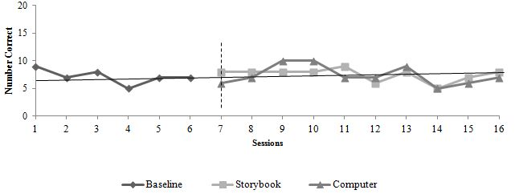

Ethan’s Comprehension Scores
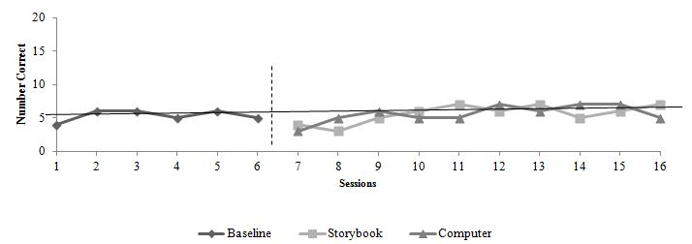

Kurt’s Comprehension Scores
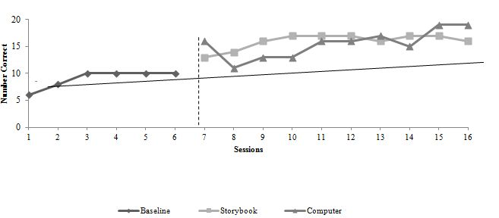

Brent’s Comprehension Scores
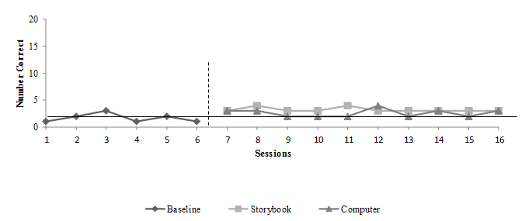

Henry’s Comprehension Scores
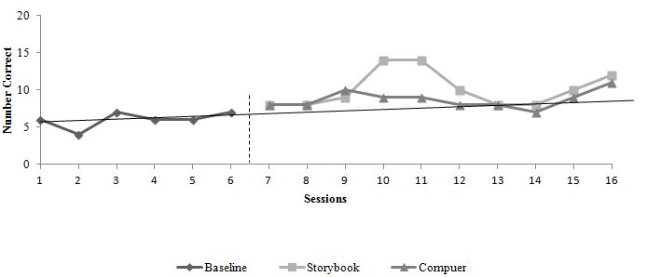

Figure 1. Intervention comprehension results

Table 2. Baseline, Storybook and Computer Intervention Comprehension Question Results

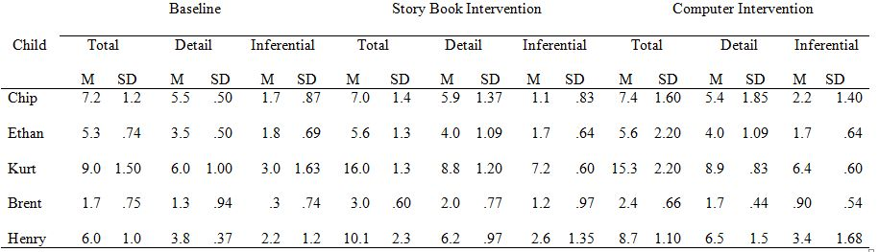

Table 3. Storybook and Computer Retelling Results

